

Practices for Secure Software Report

Table of Contents
Document Revision History 3
Client 3
Instructions 3
Developer 4
1. Algorithm Cipher 4
2. Certificate Generation 4
3. Deploy Cipher 4
4. Secure Communications 4
5. Secondary Testing 4
6. Functional Testing 4
7. Summary 4
8. Industry Standard Best Practices 4

Document Revision History

Version | Date | Author | Comments
1.0 | 6/14/26 | Kate Bippus

Client



Instructions

Submit this completed practices for secure software report. Replace the bracketed text with the relevant information. You must document your process for writing secure communications and refactoring code that complies with software security testing protocols.

- Respond to the steps outlined below and include your findings.
- Respond using your own words. You may also choose to include images or supporting materials. If you include them, make certain to insert them in all the relevant locations in the document.
- Refer to the Project Two Guidelines and Rubric for more detailed instructions about each section of the template.

Developer
Kate Bippus

Algorithm Cipher

I used the SHA-256 hashing algorithm to create a checksum. SHA-256 creates a 256-bit hash value that can be used to verify that data has not been changed. SHA-256 is a good choice because it provides a strong level of security and can be used to verify the integrity of data.

Certificate Generation
Insert a screenshot below of the CER file.

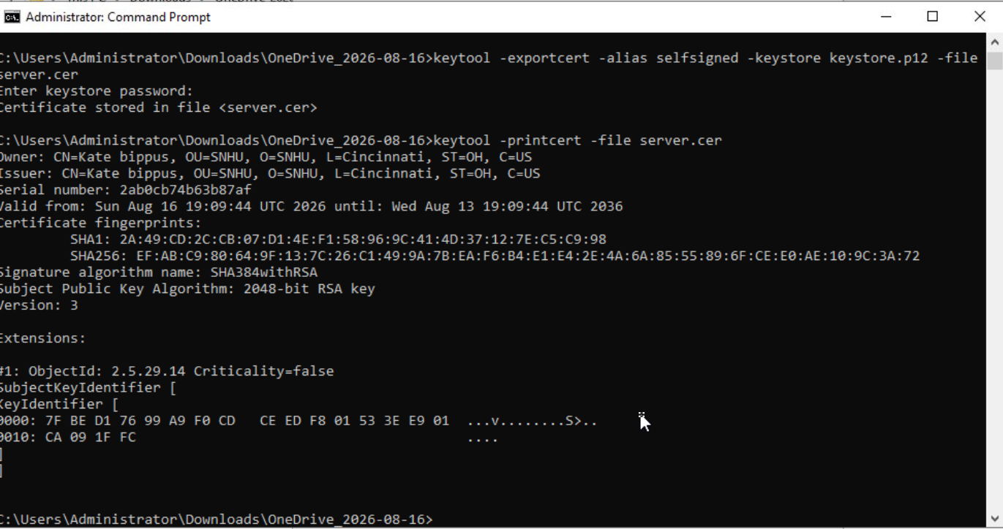

Deploy Cipher
Insert a screenshot below of the checksum verification.

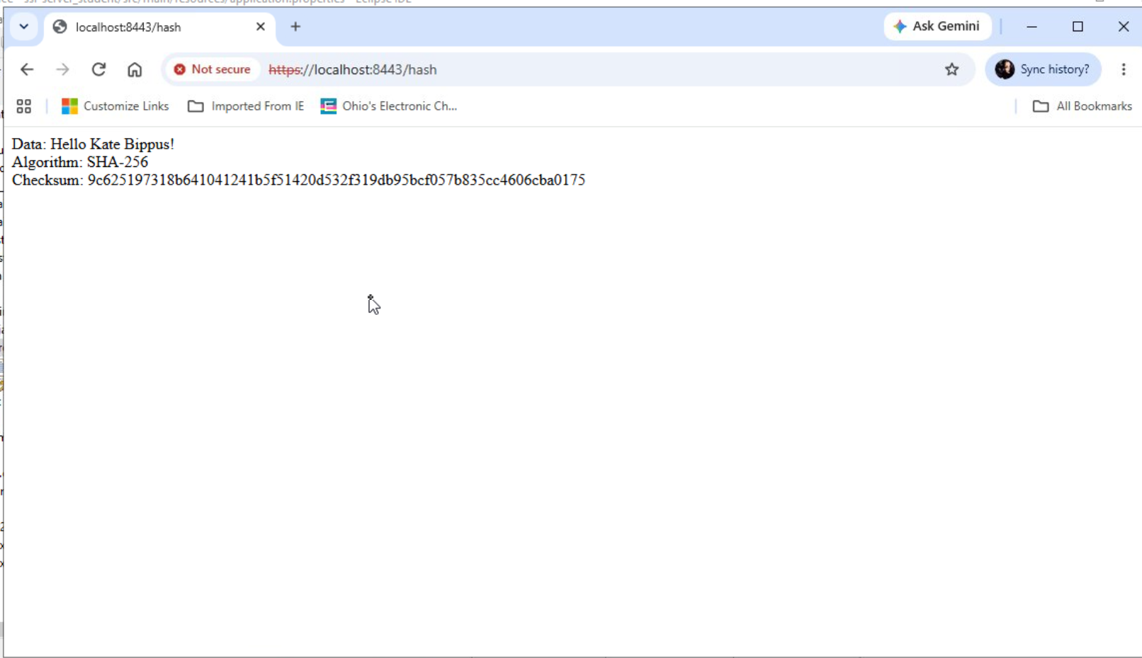

Secure Communications
Insert a screenshot below of the web browser that shows a secure webpage.

Same as above- although I couldn't get it to show “Secure”

Secondary Testing
Insert screenshots below of the refactored code executed without errors and the dependency-check report.
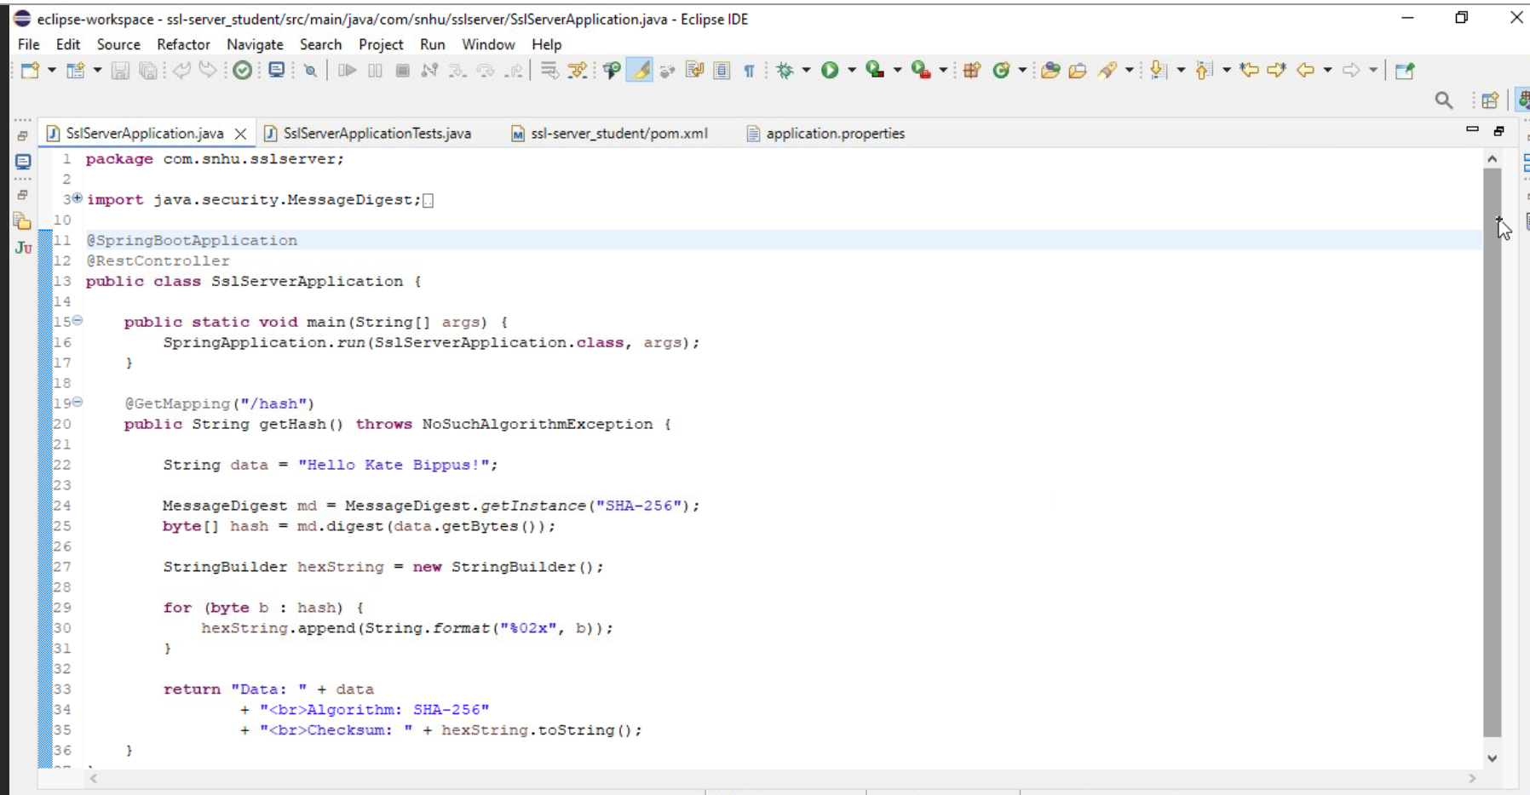
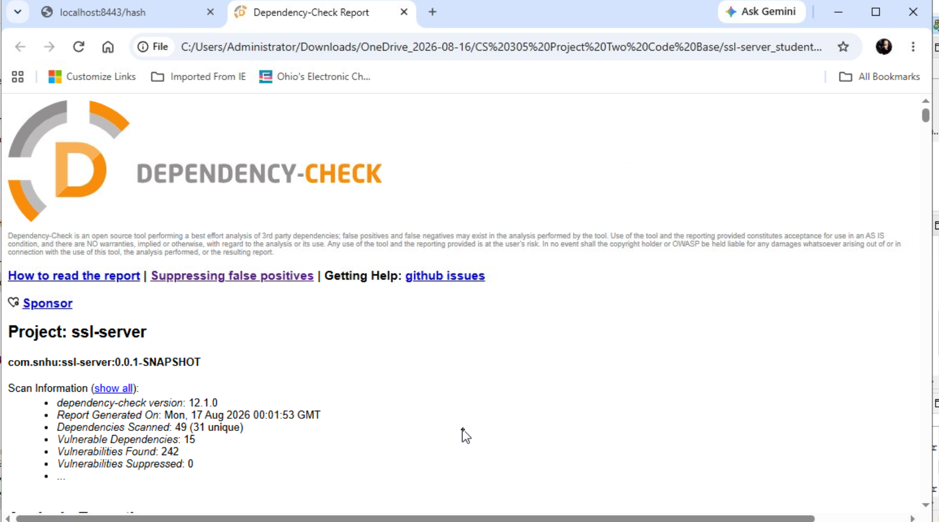

Functional Testing
Insert a screenshot below of the refactored code executed without errors.

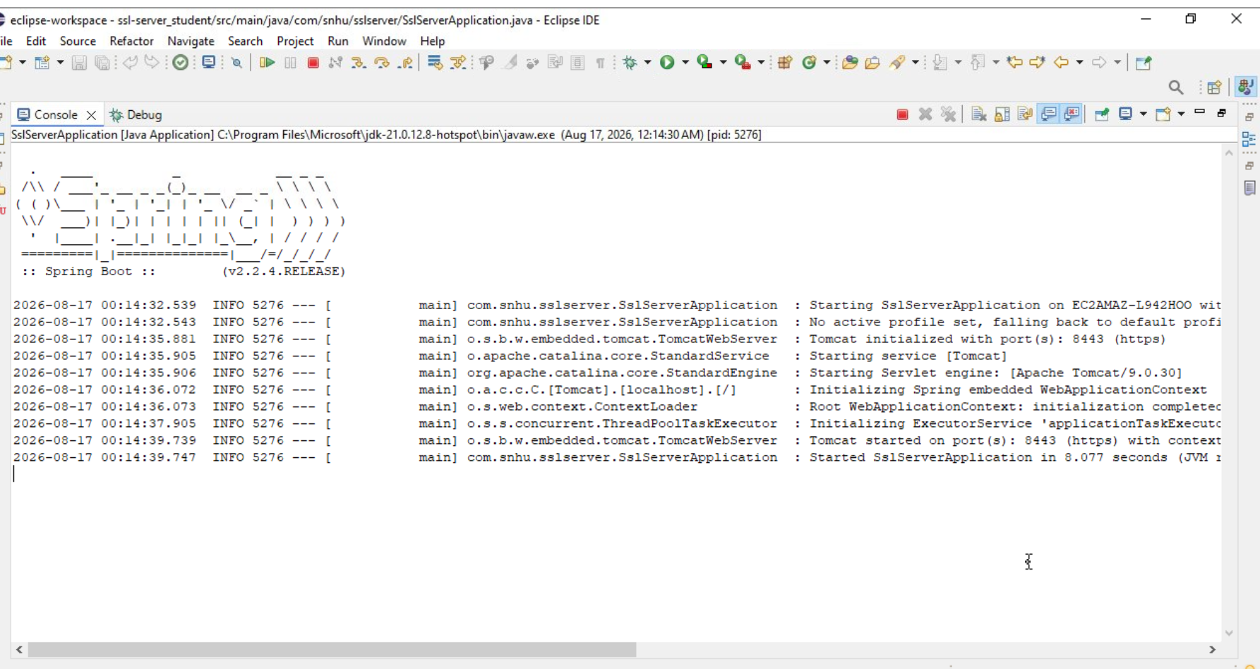

Summary
I added SHA-256 checksum verification and set up HTTPS for secure communication. I also ran OWASP Dependency-Check and tested the application after making the changes to make sure everything still worked correctly. Overall, the project showed how different security practices can work together to make an application more secure.

Industry Standard Best Practices

I followed secure coding practices by using SHA-256, HTTPS, certificates and vulnerability testing. I also tested the application after making changes to make sure the existing functionality and security still worked correctly. OWASP Dependency-Check also helped identify possible security issues within third-party dependencies.

